Tram link to airport is last piece of jigsaw
Amy Glendinning
August 05, 2010
- 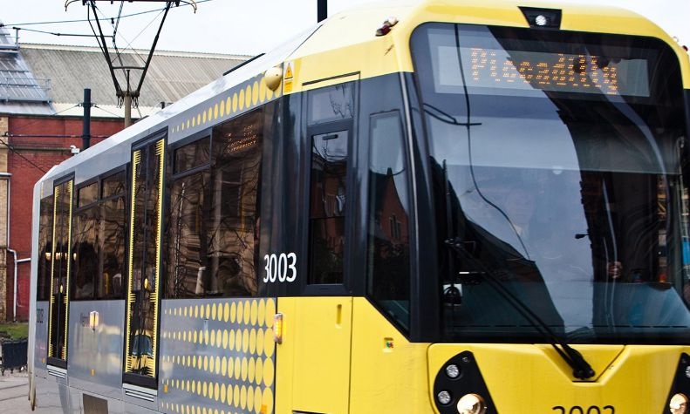
- 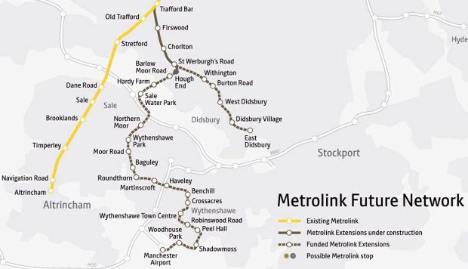

Close Map
Multi-million pound funding for the Metrolink line between Chorlton and Manchester Airport has been confirmed. Work on the line is now likely to begin within a year, with trams running by 2016.
The news has been hailed as ‘the last piece of the jigsaw’ in securing funding for a fully integrated tram system across Greater Manchester.
Funds of £398m for the airport line were signed off by the Association of Greater Manchester Authorities (AGMA) on Friday, July 30.
Manchester Airport will contribute a further £50m towards the 14.5km route.
This latest funding will be added to the £26m government money which was confirmed for the line in March.
A three per cent increase will be added to the integrated transport levy, which comes from council tax, for the next six years to complete the funding.
Levenshulme councillor and vice chair of the Greater Manchester Integrated Transport Authority (GMITA), Keith Whitmore, said: "This is really great, good news.
"This funding from AGMA is the final piece in the jigsaw which will give us a proper tramway system rather than separate lines."
Mr Whitmore added he hoped work on the airport line would start within the year after the Chorlton to Didsbury line was finished.
It will branch off from the Chorlton spur at St Werburgh’s Road, before travelling down Hardy Lane and across Chorlton Meadows.
It will then travel through Sale, Northern Moor and Baguley before reaching the airport. A 300-space park and ride car park will also be built off the M60 at Sale Water Park for people travelling to the airport.
The announcement of AGMA funding is the latest transport boost for south Manchester, which will see trams travelling along the newly constructed line between Didsbury, Chorlton and Trafford from next spring.
Funding for the airport spur was signed off as part of a £500m package from the Greater Manchester Transport Fund which will also see Metrolink lines extended to Oldham and Rochdale town centres.
Fourteen of the distinctive new yellow trams have also been ordered to run along the three routes.
Geoff Muirhead, chief executive of the Manchester Airports Group, said: "We are delighted at this news, and have been long standing supporters of the Metrolink extension since it was first proposed.
"Metrolink is a crucial addition to our services and will extend our reach into the conurbation of Greater Manchester."

